Electrocardiogram (EKG, ECG)
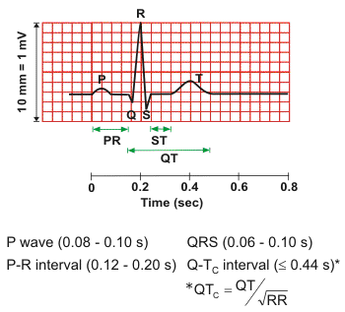
General Description
As the heart undergoes depolarization and repolarization, the electrical currents that are generated spread not only within the heart, but also throughout the body. This electrical activity generated by the heart can be measured by an array of electrodes placed on the body surface. The recorded tracing is called an electrocardiogram (ECG, or EKG). A "typical" ECG tracing is shown above. The different waves that comprise the ECG represent the sequence of depolarization and repolarization of the atria and ventricles. The ECG is recorded at a speed of 25 mm/sec, and the voltages are calibrated so that 1 mV = 10 mm in the vertical direction. Therefore, each small 1-mm square represents 0.04 sec (40 msec) in time and 0.1 mV in voltage. Because the recording speed is standardized, one can calculate the heart rate from the intervals between different waves.

P wave
The P wave represents the wave of depolarization that spreads from the SA node (sinoatrial node = pacemaker) throughout the atria, and is usually 0.08 to 0.1 seconds (80-100 ms) in duration. The brief isoelectric (zero voltage) period after the P wave represents the time in which the impulse is traveling within the AV node (atrioventricular node, where the conduction velocity is greatly retarded, allowing blood to flow from atria to ventricles) and the bundle of His.
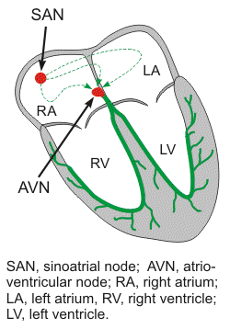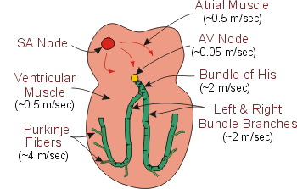
The period of time from the onset of the P wave to the beginning of the QRS complex is termed the P-R interval, which normally ranges from 0.12 to 0.20 seconds in duration. This interval represents the time between the onset of atrial depolarization and the onset of ventricular depolarization.

QRS complex
The QRS complex represents ventricular depolarization. Ventricular rate can be calculated by determining the time interval between QRS complex.
The duration of the QRS complex is normally 0.06 to 0.1 seconds. This relatively short duration indicates that ventricular depolarization normally occurs very rapidly. If the QRS complex is prolonged (> 0.1 sec), conduction is impaired within the ventricles.
The shape of the QRS complex in the figure above is idealized. In fact, the shape changes depending on which recording electrodes are being used. The shape will also change when there is abnormal conduction of electrical impulses within the ventricles. The figure below summarizes the nomenclature used to define the different components of the QRS complex.
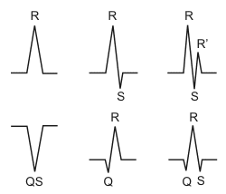

ST segment
The isoelectric period (ST segment) following the QRS is the time at which the entire ventricle is depolarized and roughly corresponds to the plateau phase of the ventricular action potential. The ST segment is important in the diagnosis of ventricular ischemia (a restriction in blood supply to tissues, causing a shortage of oxygen and glucose needed for cellular metabolism to keep tissue alive) or hypoxia ( deprived of adequate oxygen) because under those conditions, the ST segment can become either depressed or elevated.

T wave
The T wave represents ventricular repolarization and is longer in duration than depolarization (i.e., conduction of the repolarization wave is slower than the wave of depolarization).

Q-T interval
The Q-T interval represents the time for both ventricular depolarization and repolarization to occur, and therefore roughly estimates the duration of an average ventricular action potential. This interval can range from 0.2 to 0.4 seconds depending upon heart rate. At high heart rates, ventricular action potentials shorten in duration, which decreases the Q-T interval. Prolonged Q-T intervals can be diagnostic for susceptibility to certain types of tachyarrhythmias (rapid heart rate).
ECG tracings recorded simultaneously from different electrodes placed on the body produce different characteristic waveforms.

Summary Results of a Cardiac Stress Test indicating a Major Heart Problem
Indiana, Pennsylvania

Standard Reference EKG / ECG | Patient at Rest

Patient During Short Stress Test  (less than two minutes) | Patient During Short Stress Test  (less than two minutes)

Patient During Recovery after Stress Test | Patient During Recovery after Stress Test

The patient was Dr. Ray L. Winstead, retired IUP Biology Professor and editor of this handout. The attending physician in Indiana, PA stopped the test after less than two minutes, noting that the test indicated a major problem. Eighteen hours later in Johnstown, PA I had open heart, triple coronary bypass surgery. The basic analysis below of the stress test EKG strips is from information supplied by Dr. Andy Browe, physiologist and retired IUP Biology Professor, as well as one of the three founders of the Cardiac Rehabilitation Program in Indiana, PA.

“What your EKG indicates during your stress test is a classic case of coronary ischemia in the left ventricle.” [Ischemia is a restriction in blood supply to tissues, causing a shortage of oxygen and glucose needed for cellular metabolism.] “This coronary ischemia did not show up on the EKG when you were at rest. The changes in your EKG during the onset of exercise occurs primarily in leads V4, V5, V6 and lead II; all indicative of a problem with the left ventricle. The changes in your EKG are called S-T depression. Normally the S-T line is at the isoelectric point and the T wave is a positive wave, both indicating normal ability to repolarize the cardiac muscle fibers in the left ventricle. Repolarization of muscle fibers is an active process requiring activity of the Na⁺ - K⁺ pump (and Ca⁺⁺ pump) to restore normal K⁺ / Na⁺ / Ca⁺⁺ ion concentrations across the muscle fiber membrane after a rapid depolarization. The increased Na⁺ - K⁺ pump activity requires the continuous synthesis of ATP. This synthesis of ATP occurs primarily by aerobic metabolism in cardiac muscle fibers and thus requires a continuous supply of oxygen. Thus if the coronary circulation to the left ventricle is insufficient (particularly during exercise) then there will be an inadequate supply of oxygen and thus a reduced ATP production in the cardiac fibers. This reduction in ATP will reduce Na⁺ - K⁺ pumping and thus alter (slow) the repolarization process. This slowing of repolarization of many cardiac fibers is revealed by a change in the S-T level, thus the S-T depression, and sometimes an inversion of the T wave. The fact that the S-T depression is rapid and progressive upon mild exercise is strongly indicative of a significant decline in coronary blood flow to the left ventricle. This is what caught the attending physician’s (RW: and my!) immediate attention (RW: since I could also see the EKG monitor). It is certainly possible that the stress test EKG revealed an impending myocardial infarction before it happened to you.” [A myocardial infarction is a heart attack. It happens when blood stops flowing properly to part of the heart and the heart muscle is injured due to not receiving enough oxygen.] “In that sense you are a very fortunate individual. By attending to your vague and mild symptoms (shortness of breath, and some abnormal chest feeling) you effectively prevented a much more serious event from possibly happening.” “In addition your heart rate and blood pressure were higher than you would normally predict at low intensity exercise. This indicates a lower than normal stroke volume and thus a compromised pumping ability of your heart during mild exercise.”

